Condenser Microphone
CP025
Image:
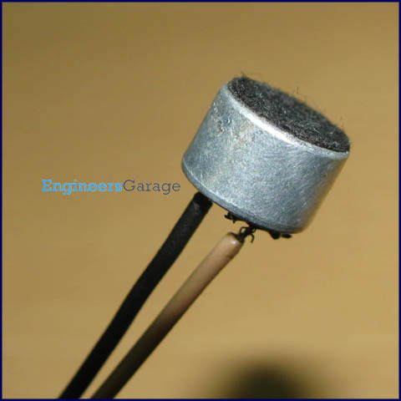
Condenser microphone (mic) is a transducer that uses a capacitor (or condenser) to convert acoustical energy into electrical energy. The sound waves result into electric signals that can be used to drive a circuit or device. The pin connected to the case of mic is connected to ground and the other pin gives the output.
A simple capacitor has two plates with a voltage difference between them. The capacitance depends on the distance between these plates. In condenser mic, a diaphragm (of light material) acts as one of the plates. When sound waves strike the diaphragm, the distance, between the plates, changes and so does the capacitance. When the plates come closer, thereby increasing the capacitance, a charge current is generated. Similarly, the capacitance decreases and a discharge current occur when the plates move apart.
There are two methods of extracting sound signals from mic, namely, DC biased and radio frequency (RF). In DC biased method, the charge within the capsule, i.e., diaphragm and fixed plate assembly, remains constant. The voltage variations, across the capsule, are passed through a series resistor and are further amplified. In RF method either the capacitance change modulates the amplitude of output of a low RF oscillator or the capsule is a part of a resonant circuit which modulates the frequency of output. Learn about working and internal structure of a condensor microphone.

Pin Diagram:
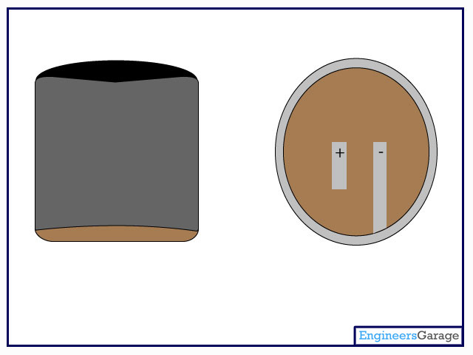

Insight - How Electret Condenser Microphone works

Table of Contents:
- Insight - How Electret Condenser Microphone works
- Top View
- Capacitor Plates
- Diaphragm & Spacer
- Electrical Connection &JFET
Transducers are devices which convert energy from one form to other. A microphone is a transducer which converts sound energy to electrical signals. It works opposite to a speaker (see how speaker works). Microphones are available in different shape and sizes. Depending on the application, a microphone may use different technologies to convert sound to electrical signals. Here we are going to discuss about the Electret Condenser Microphone which is widely used in mobile phones, laptops, etc.

Electret Condenser Microphone, as the name suggests is a parallel plate capacitor and works on the principle of a variable capacitance. It consists of two plates, one fixed (called the back plate) and the other moveable (called Diaphragm) with a small gap between them. An electric potential charges the plate. When sound strikes the diaphragm it starts moving, thereby changing the capacitance between the plates which in turn results in a variable electric current to flow.

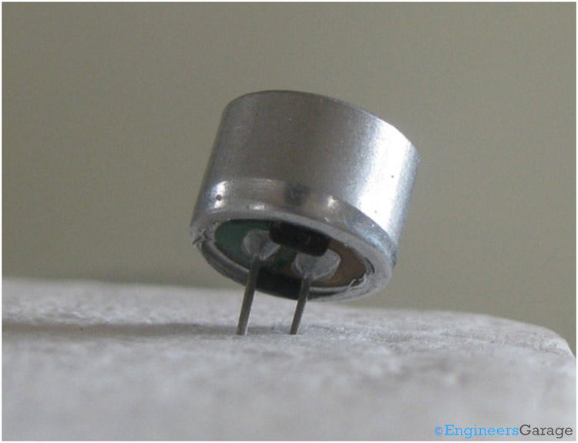
The above image shows an Electret microphone. These microphones are widely used in electronic circuits to detect minor sounds or air vibrations which in turn are converted to electrical signals for further use. The two legs as shown in the image above are used to make electrical connection with the circuit.
Porous Covering
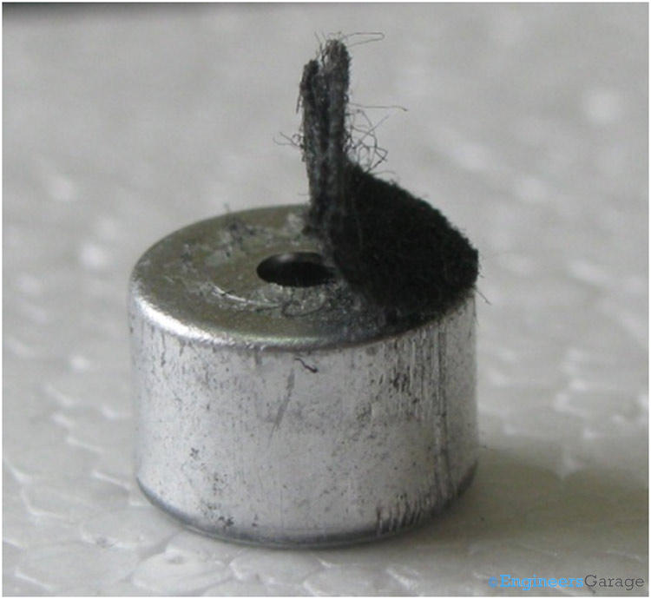
A solid conducting metal body encapsulates the various parts of the microphone. The top face is covered with a porous material with the help of glue. It acts as a filter for the dust particles. The sound signals/air vibrations passes through the porous material and falls on the diaphragm through the hole shown in the image above.
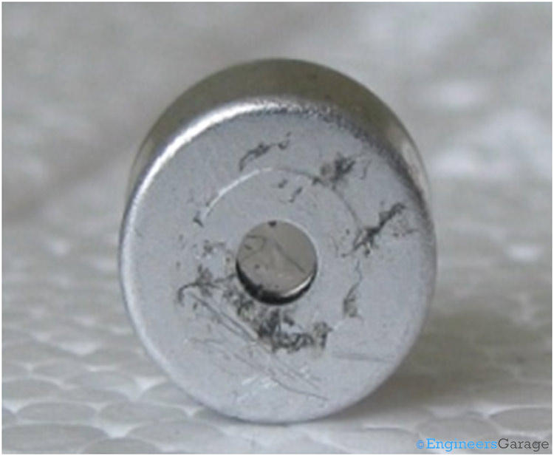
The diaphragm through the hole can be seen in the image above.

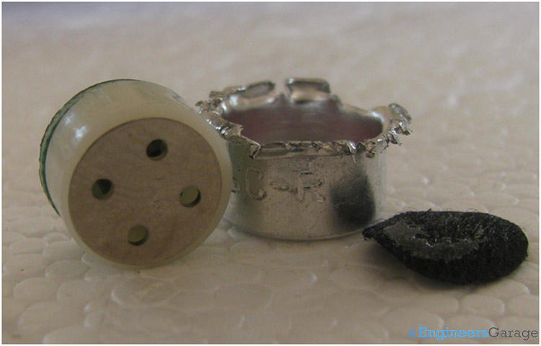
On removing the metal body, a cylindrical plastic covering can be seen which provides the mechanical strength and supports the entire assembly. This entire assembly is called the capsule.

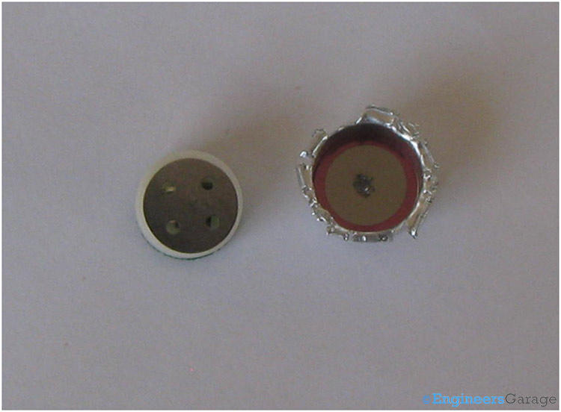
The two plates of the capacitor, which is the heart of the condenser microphone is shown in the image above. The diaphragm (inside the metal body) is a very thin film of conducting metal. It is deformable and elastic in nature. The diaphragm is pasted on a solid hollow ring which provides the necessary support to the diaphragm. The back plate is a thick solid perforated metallic plate. It is coated with a permanently charged electret material to eliminate the need of polarized power supply. These electrets are made by melting a dielectric material (like wax, plastic, etc) that contains polar molecules and solidifying them back in a strong electrostatic field. The polar molecules of the dielectric material are inclined towards the direction of electrostatic field and create a permanent electrostatic bias in them. In the modern microphones, PTFE (Poly Tetra Fluoro Ethylene) plastic is used to form the electric material.

The design of the holes plays a very vital role in reducing the air damping and mechanical thermal noise. The two plates have a small gap between them to allow the movements of diaphragm. A very fine thin film of plastic is placed between the two plates to provide electrical insulation. The diaphragm moves in the air gap between the plates with the slightest disturbance caused in the surrounding air pressure by the sound signal.
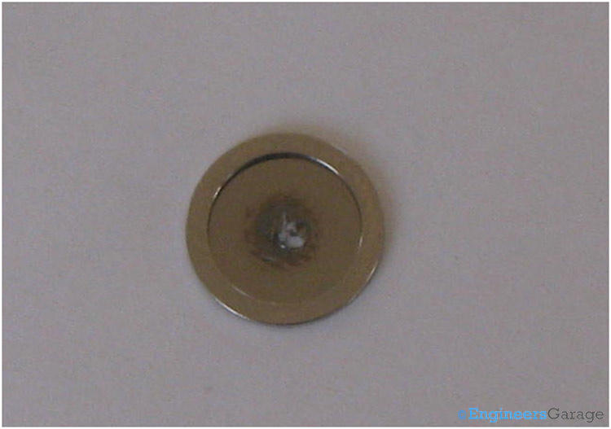
The solid hollow ring of the diaphragm is used to connect the diaphragm with the outer metal covering.

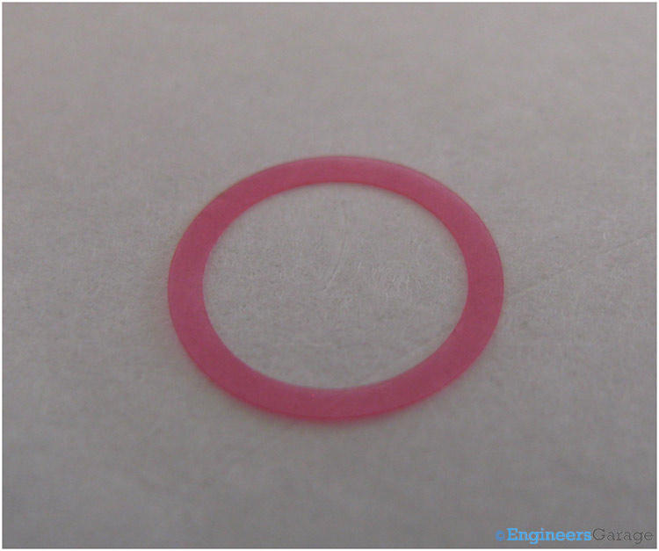

A very thin plastic spacer is placed between both the plates to insulate them as well as provide the gap to move the diaphragm.

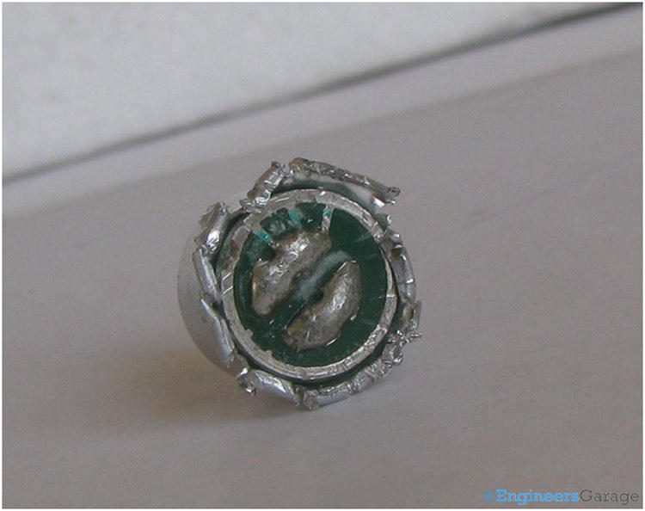
The diaphragm is electrically connected to one of the legs of the microphone via the outermost metallic covering.

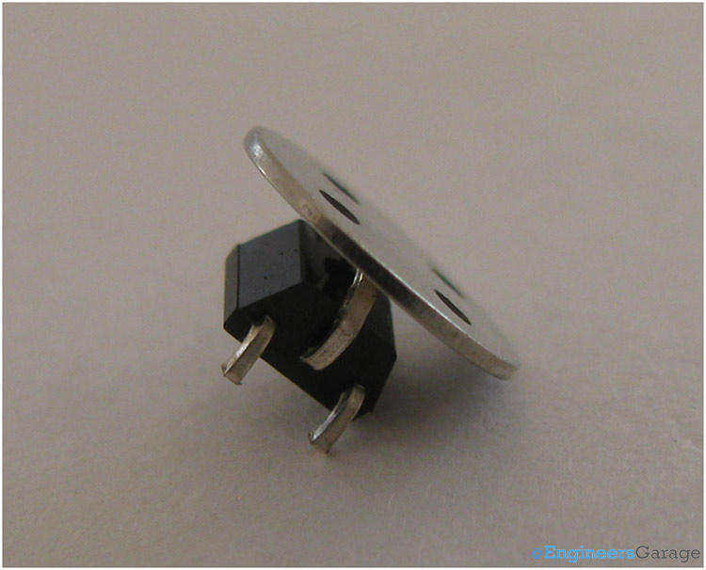
A JFET (Junction Field Effect Transitor) transistor is used to amplify the electrical current generated. The back plate, fixed in the capsule, is connected with the gate of the transistor, source is connected with the ground of the external circuit and electrical signal appears on the drain.

Working:
Sound creates vibrations in surrounding air particles. When a sound is produced near the microphone, vibrating air particles strikes the diaphragm. The resultant air pressure moves diaphragm changing the distance between the plates. The electret material pasted on the back plate, maintains a constant static charge across the capacitor. Relation between the voltage, charge & capacitance is formulated as V=Q/C.

Capacitance of a capacitor depends on the distance between its plates. When the air pressure makes the diaphragm move back and forth, capacitance varies accordingly and thus voltage varies too. This varying voltage produces a variable electric current which is in accordance with the sound vibrations at the diaphragm.

